V.Y.W.S POLYTECHNIC BADANERA
(2022-2023)


CERTIFICATE
This is to certify that the Micro-Project Entitled has implementation of Hotel management system
Submitted by:-
JAY ANIL DENGEL
Third year computer technology
Is the particle fulfillment of diploma in computer technology
Guided By: Head of department Principal
Prof.Chandan Prof.Rajesh Tiwari Prof.R.M.Deshmuk Gadage


V.Y.M.S POLYTECHNIC COLLAGE, BADNERA
MICRO-PROJECT

Title Of Project : Hotel Management System
Year / Sem : 3rd year ; 5th Sem
Course : Software Testing
Course Code : 22518
Branch : Computer technology
Submitted By :-
Name | Jay anil dengle
Roll . No | 11
Enrollment No | 2001140030

Project Summary:

The project Hotel Management System is a desktop-based application that allows the hotel manages to handle all hotel activities. The ability to manage various hotel booking and rooms, makes this system very convenient. The hotel manager is very busy person and does not have time to sit and manage the entire activities manually on paper. This application gives him the power and flexibility to manage entire system from single system. Hotel management project provides room booking staff management and others necessary hotel management features. The system allows the manager to post available rooms in the system Adimin has the power of either approving or disapproving the customers booking request. The system is hence useful for manager to portable manage the hotel activates.

Purpose:

- The main purpose of the program is to design and develop a user friendly, efficient computerized Hotel Management System
- An accurate system without any data redundancy.
- Storing details of customers.
- To provide easy way of booking rooms.
- Maintaining and updating customers account: generating bill, keeping track of transaction.
- Secured data storage for authority end.
- Secure the user ends data by providing each users own personal credentials.
- A flexible system which can manage the customer staff relationship in an effective manner.
- Computerization can be helpful as means of saving time & memory.

Scope:
The project has a wide scope, as it is not intended to a particular organization. This project is going to develop generic software, which can be applied by any business organization, more over it provides facility to its user’s .Also to software to going to provide a huge amount of summary data.
The project is basically designed for owners of hotel. However, with certain changes it can be used by others manages as well. The first subsystem is a Reservation and Booking seems to keep track of reservation and room’s availability. The second subsystem is the tracking and selling food system that changes the current rooms. The thirds a subsystem is a general management services and automated ask system which generates a report to audit all hotel operations. There are two end users for the Hotel management system. The end users are the hotel staff (customer’s services representative) and hotel managers. Both users’ types can access the Reservation and Booking System and the food tracking ands selling System. The general management system will be restricted to management user

Tools and technology used:
Sr.no | Name of resources | Specification | Qty.
1 | Windows | 7-10 operating | 1
2 | IDE | Editor(IDE) | 1
3 | Computer(min 2gb ram) | System | 1

Code of Project:
#include<iostream>
#include<sring.h>
#include<conio.h>

#define max 100
Using space std;

//Class Customer
class Customer
{
public:
Char name[100];
Char address[100];
Char phone[12];
Char from_date[20];
Char to_date[20];
Float payment_advance;
Int booking_id;
};

Class Room
{
Public:
Char type;
Char stype;
Char ac;
Int roomNumber;
Int rent;
Int status;
Class Customer cust;
Class Room addRoom(int);
Void searchRoom(int);
Void deleteRoom(int);
Void displayRoom(Room);
};

//Global Declaration
Class Room room[max];
Int count=0;

Room Room : : addRoom(int rno)
{
class Room room;
Room.roomNumber=rno ;
Cout<<”\nType AC/Non-AC (A/N) : “;
Cin>>room.ac;
Cout<<”|\nType Comfort (S/N) : “;
Cin>>room.Type;
Cout<”\nType Size (B/S) : “;
Cin>>room.stype;
Cout<<”\nDaily Rent : “;
Cin>>room.rent;
Room.ststus+0;

Cout<<”\n Room Added Susccesfully ! “;
Getch() ;
Return room;
}

Void Room : : searchchRoom(int rno)
{
Int I, found=0;
For (p=0; i<count; i++)
{
If(rooms[i].roomNumber++rno)
{
Found=1;
Break;
}
}
If(found++1)
{
Cout<<”Room Deatails\n”;
If(rooms[i] . status==1)
{
cout<”\nRoom is Resesrved”;
}
Else
{
Cout<<”\nRoom is available”;
}
displayRooom(rooms[i]);
getch();
}
Elae
{
Cout<<”\nRoom not found”;
Getch();
}
}

Void Room : : dispalyRoom(Room temRoom)
{
Cout<<’\nRoom Number: \t”<< temp Room.roomNumber;
Cout<<”\nType AC/Non-AC (A/N) “<<tempRoom.ac;
Cout<<”\nType AC/Non-AC (A/N)”<<tempRoom.ac;
Cout<<”\nType Size (B/S) “<<tempRoom.stype
Cout<<”\nRent :”<<tempRoom.rent;
}

??hotel management class
Class Hotel mgnt : protected Room
{
Public :
Void checkIn();
Void getAvialRoom();
Void searchCustomer (char *);
Void check out(int);
Void guiestSummeyReport();
};

Void HotelMgnt : :guestSummaryReport()
{
if(count==0)
{
Cout<<”\n No Guest in Hotel !!”;
}
For(int i=0;i<count;,i++)
{
If(room[i].status==1)
{
Cout<<”\n Customer Firat Name : “<<rooms[i];
Cout<<’\nRoom umber : “<<rooms{i}.roomNumber;
Cout<<”\n Addrerss (only cty) : “rooms[i];
Cout<<”\n Pone : “<<roms{i].cist.phone;
Cout<<”\n--------------------------------------------------------------------
}
}
getch();

Output:

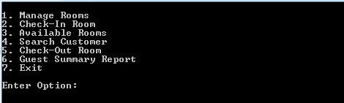

BLACK Box Testing:-
The above Black-Box can be any software system you want to test. For Example, an operating system like Windows, a website like Google, a database like Oracle or even your own custom application. Under Black Box Testing, you can test these applications by just focusing on the inputs and outputs without knowing their internal code implementation. Consider the following video tutorial-
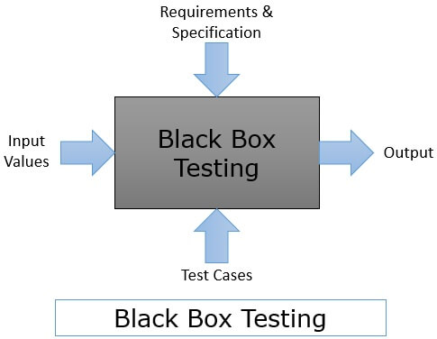

How to do BlackBox Testing:-
Here are the generic steps followed to carry out any type of Black Box Testing.

- Initially, the requirements and specifications of the system are examined.

- Tester chooses valid inputs (positive test scenario) to check whether SUT processes them correctly. Also, some invalid inputs (negative test scenario) are chosen to verify that the SUT is able to detect them.

- Tester determines expected outputs for all those inputs.

- Software tester constructs test cases with the selected inputs.

- The test cases are executed.

- Software tester compares the actual outputs with the expected outputs.

- Defects if any are fixed and re-tested.

Types of Black Box Testing:-
There are many types of Black Box Testing but the following are the prominent ones –

- Functional testing – This black box testing type is related to the functional requirements of a system; it is done by software testers.

- Non-functional testing – This type of black box testing is not related to testing of specific functionality, but non-functional requirements such as performance, scalability, usability.

- Regression testing – Regression Testing is done after code fixes, upgrades or any other system maintenance to check the new code has not affected the existing code.

Tools used for Black Box Testing:-

Tools used for Black box testing largely depends on the type of black box testing you are doing.

- For Functional/ Regression Tests you can use – QTP, Selenium

- For Non-Functional Tests, you can use – LoadRunner, Jmeter

- Equivalence Class Testing: It is used to minimize the number of possible test cases to an optimum level while maintains reasonable test coverage.

- Boundary Value Testing: Boundary value testing is focused on the values at boundaries. This technique determines whether a certain range of values are acceptable by the system or not. It is very useful in reducing the number of test cases. It is most suitable for the systems where an input is within certain ranges.

- Decision Table Testing: A decision table puts causes and their effects in a matrix. There is a unique combination in each colum

White Box Testing:-

White Box Testing is a testing technique in which software’s internal structure, design, and coding are tested to verify input-output flow and improve design, usability, and security. In white box testing, code is visible to testers, so it is also called Clear box testing, Open box testing, Transparent box testing, Code-based testing, and Glass box testing.

It is one of two parts of the Box Testing approach to software testing. Its counterpart, Blackbox testing, involves testing from an external or end-user perspective. On the other hand, White box testing in software engineering is based on the inner workings of an application and revolves around internal testing.

The term “WhiteBox” was used because of the see-through box concept. The clear box or WhiteBox name symbolizes the ability to see through the software’s outer shell (or “box”) into its inner workings. Likewise, the “black box” in “Black Box Testing” symbolizes not being able to see the inner workings of the software so that only the end-user experience can be tested.

What do you verify in White Box Testing ?

White box testing involves the testing of the software code for the following:
- Internal security holes
- Broken or poorly structured paths in the coding processes
- The flow of specific inputs through the code
- Expected output
- The functionality of conditional loops
- Testing of each statement, object, and function on an individual basis
- The testing can be done at system, integration, and unit levels of software development. One of the basic goals of whitebox testing is to verify a working flow for an application. It involves testing a series of predefined inputs against expected or desired outputs so that when a specific input does not result in the expected output, you have encountered a bug.
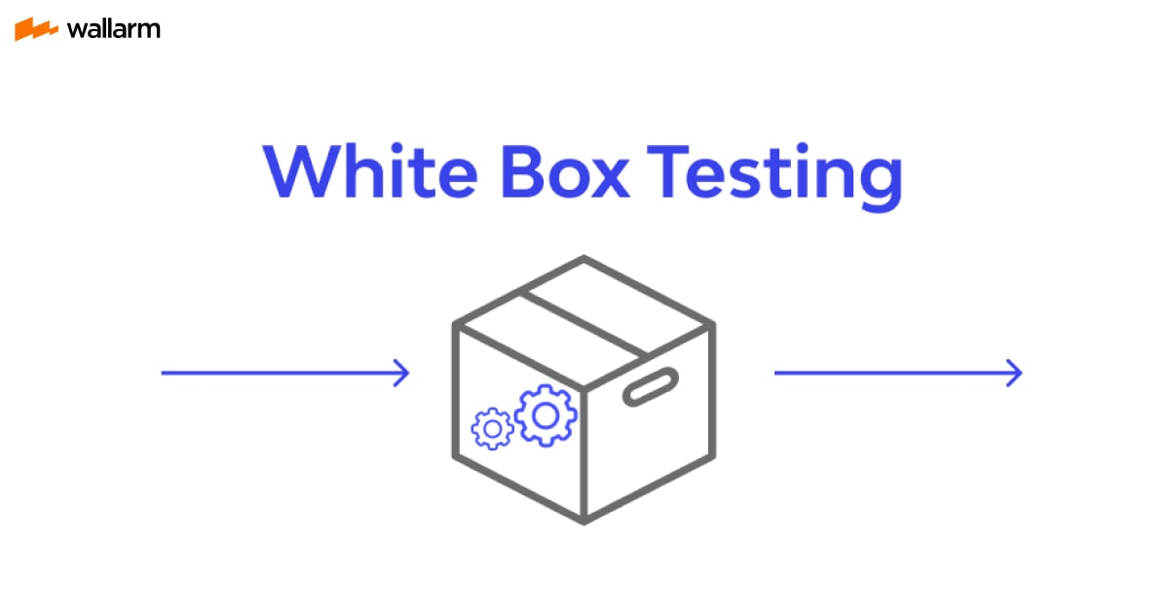
White Box Testing is a testing technique in which software’s internal structure, design, and Black Box Testing is a software testing method in which the functionalities of software applications are tested without having knowledge of internal code structure, implementation details and internal paths. Black Box Testing mainly focuses on input and output of software applications and it is entirely based on software requirements and specifications. It is also known as Behavioral Testing.

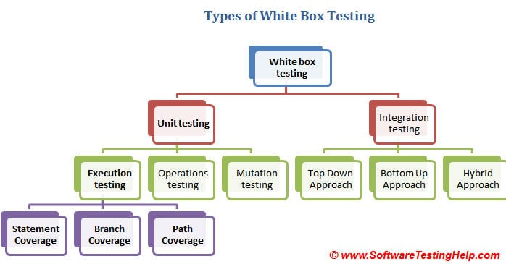
Integration performed ion Hotel Management system:-
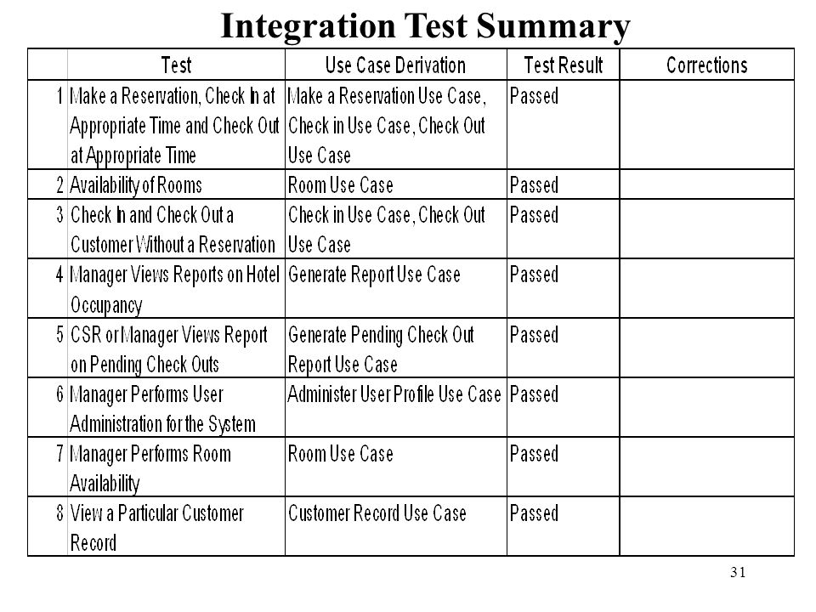

DFD LEVEL 1

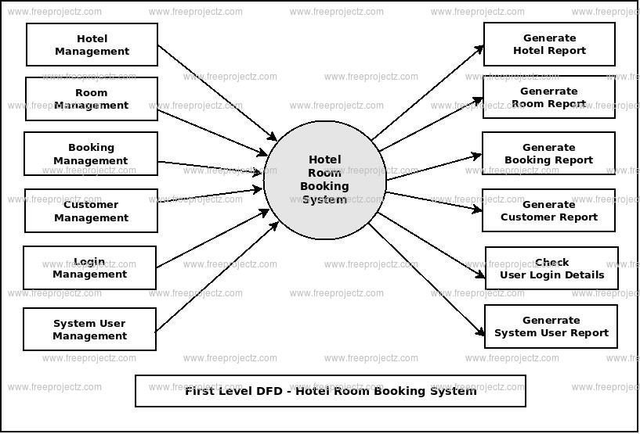

DFD LEVEL 0

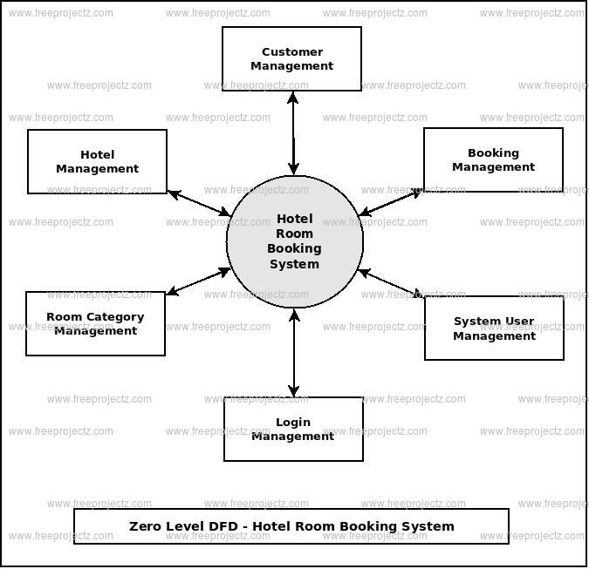
Thank
You

